ACPR IT and Outsourcing Instructions Compliance for Log360
Tagline: Support ACPR IT and outsourcing security compliance with centralized monitoring from Log360

Overview
The ACPR IT and Outsourcing Instructions Compliance extension for Log360 helps French banks, insurance companies, and financial institutions supervised by the Autorité de Contrôle Prudentiel et de Résolution (ACPR) meet the IT governance, outsourcing oversight, and information security monitoring requirements of ACPR's supervisory instructions.
Log360 collects and correlates logs from financial systems, cloud environments, outsourced service platforms, and network infrastructure, providing continuous visibility into IT security events. Compliance teams can monitor outsourced services, detect anomalies, and generate audit documentation for ACPR inspections.

Key Features
- Generate predefined audit reports aligned to ACPR IT and Outsourcing Instructions covering access management, system monitoring, and security incident detection.
- Monitor outsourced service activity and third-party access events to detect unauthorized operations and supply chain security risks.
- Track privileged user activities and administrative changes across financial IT environments and cloud platforms in real time.
- Export ACPR-ready compliance evidence in PDF and CSV formats for supervisory examinations and internal financial IT governance reviews.



Screenshots
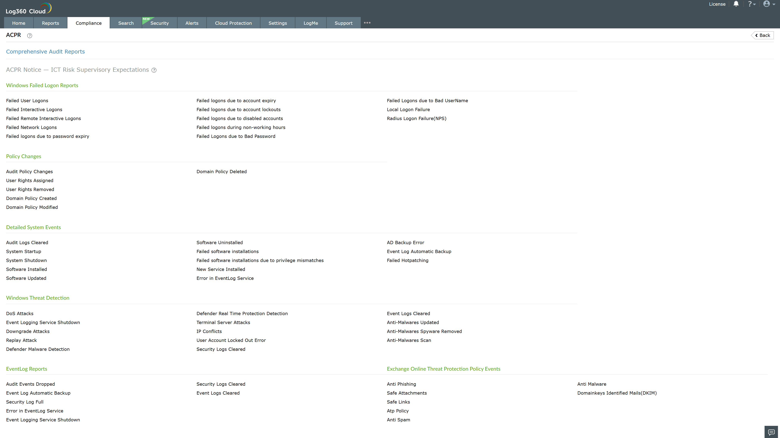
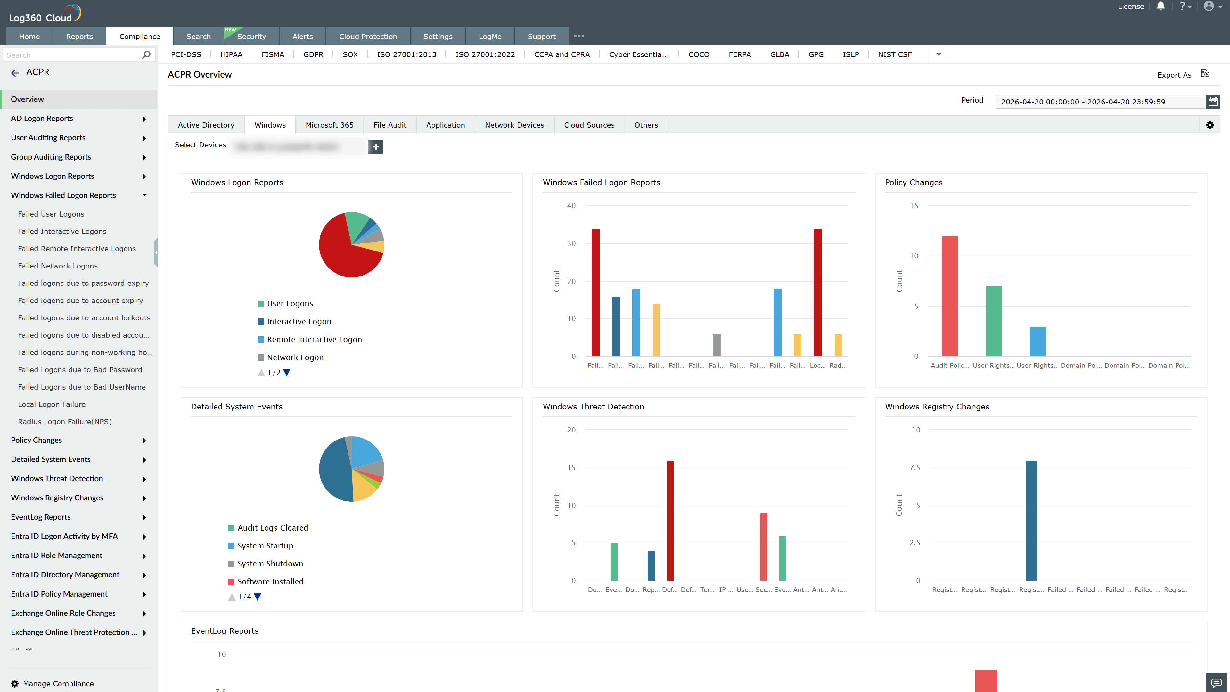
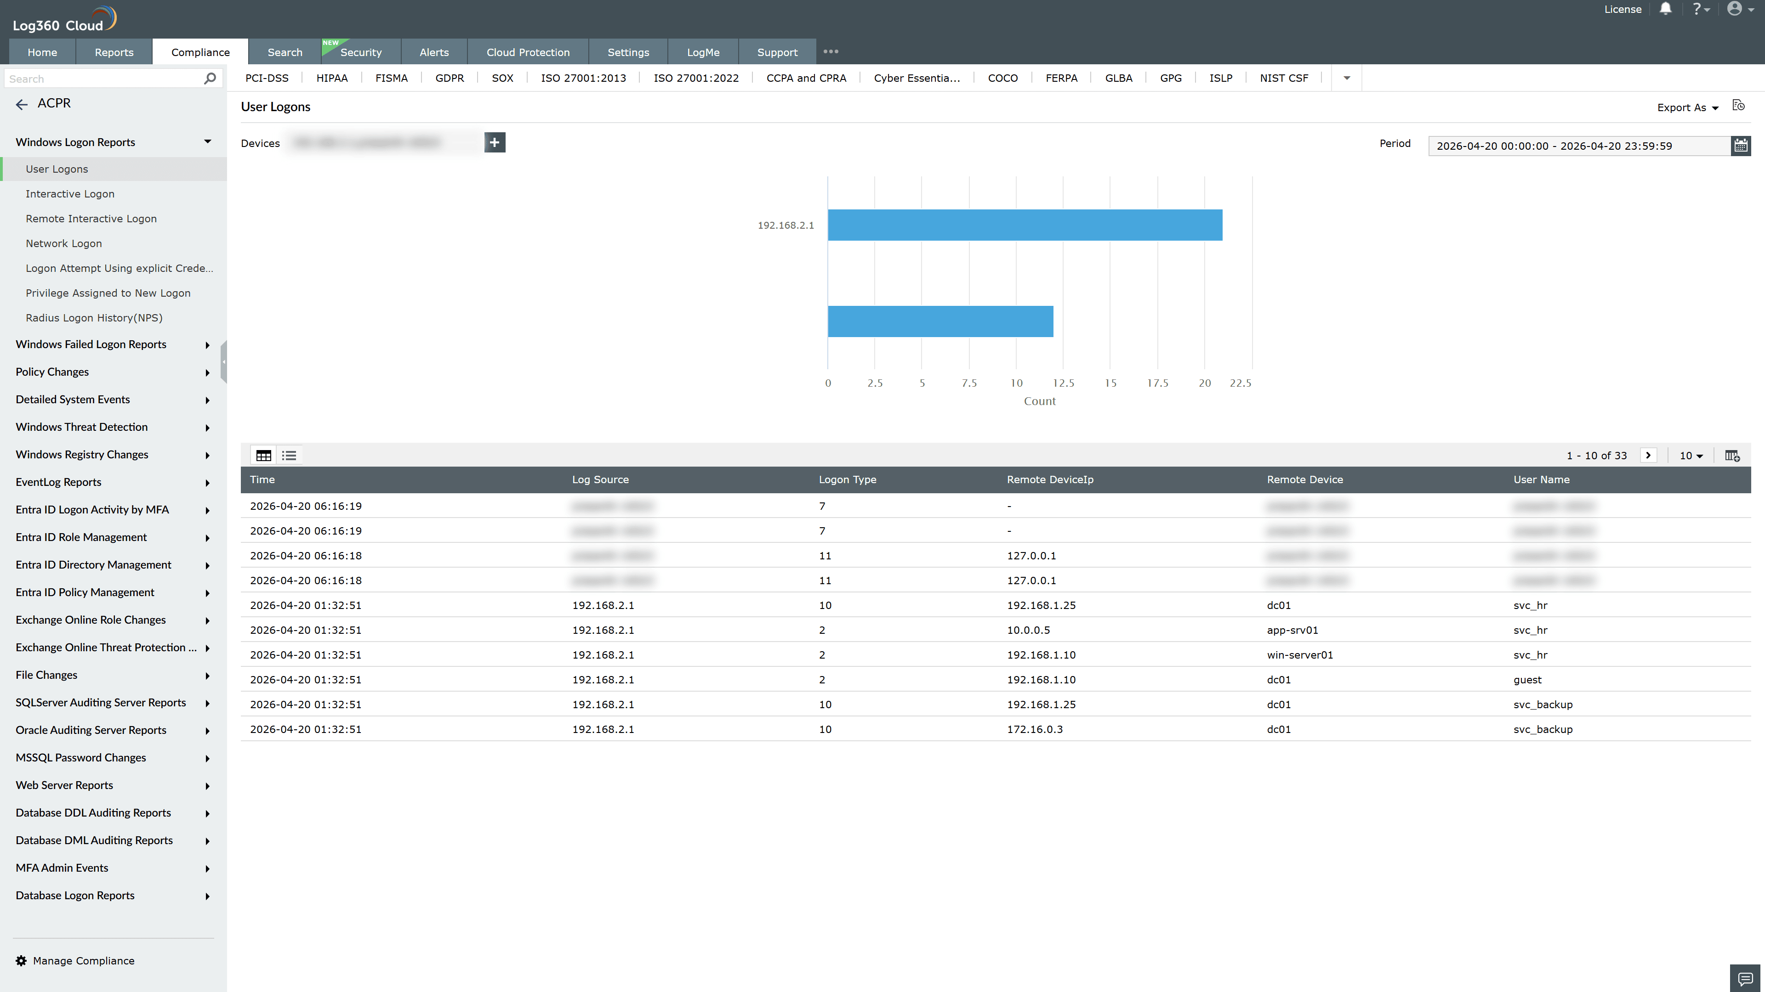
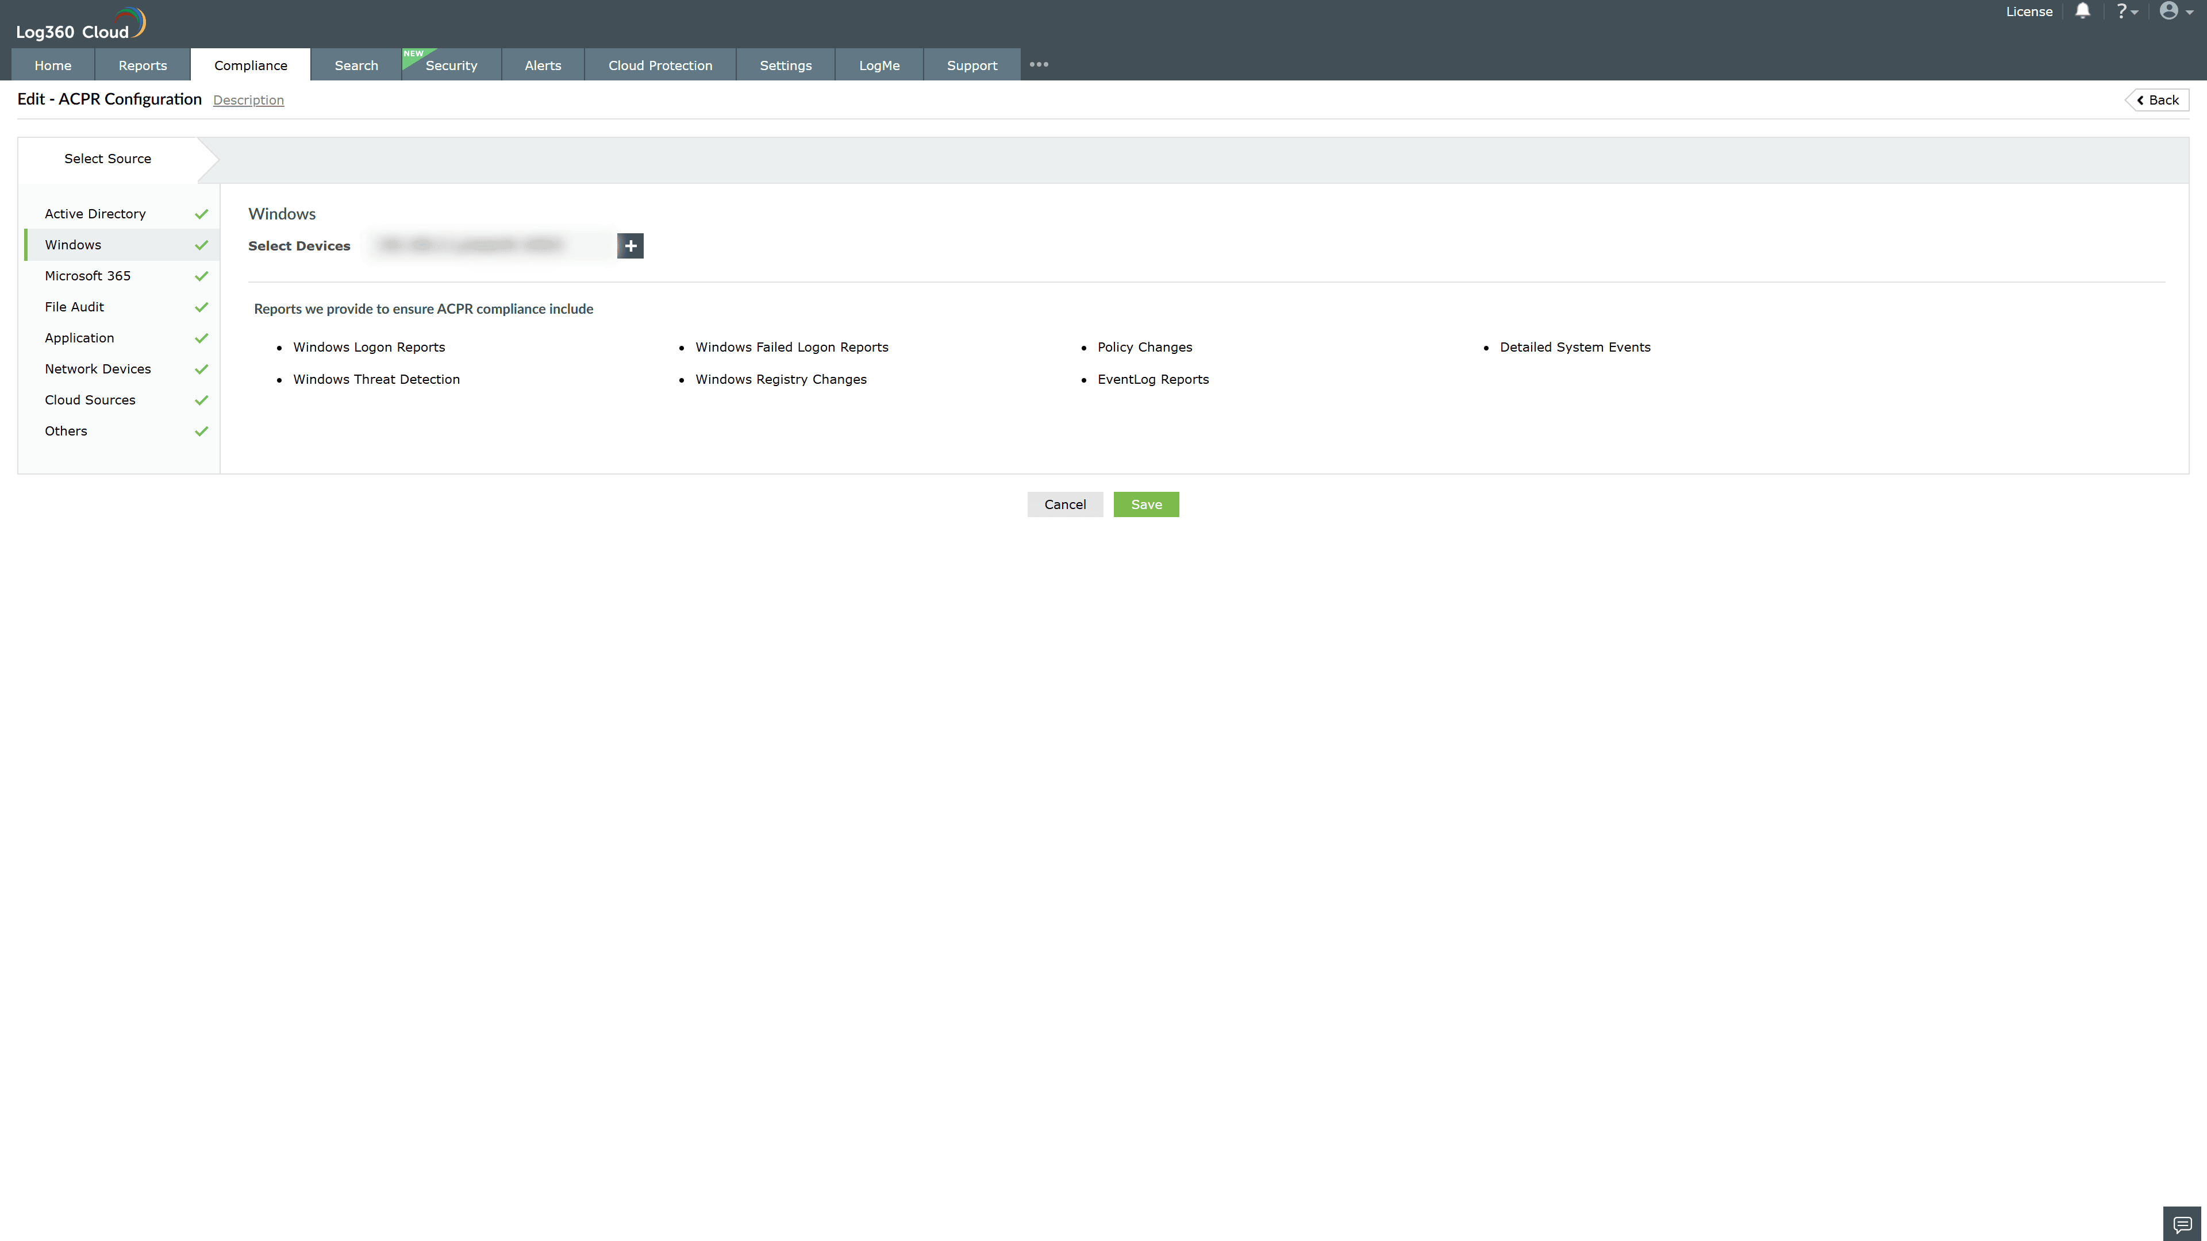
Valid Submission : Yes
Supported Editions : Free, Basic, Standard, Professional, MSSP
Help Document : https://www.manageengine.com/log-management/help/integrations/compliance-extensions.html
Help Video : Not provided
Tags : Log360, Compliance, Privacy monitoring, Data privacy, Regulatory compliance
Supported DCs : US, IN, JP, CA, AU, UK and EU
Privacy Policy:
Terms of Service:
Release Notes:
Predefined reports for the ACPR IT and Outsourcing Instructions Compliance

